**Application and Messaging Service**

1. SNS (Simple Notification Service)
   1. SES (Simple Email Service)
2. SQS (Simple Queue Service)
3. Amazon MQ (Amazon Message Queue)
4. SWF (Simple Work Flow)
5. API Gateway
6. **SNS**
   1. Application Interface -> SNS -> Create Topic -> Give a endpoint
      1. Subscribers can subscribe to the endpoint
         1. URL
         2. Post/send
         3. Email address
         4. SQS
         5. Mobile push messages (to send email notification)
         6. Lambda msgs
         7. Sms text messages

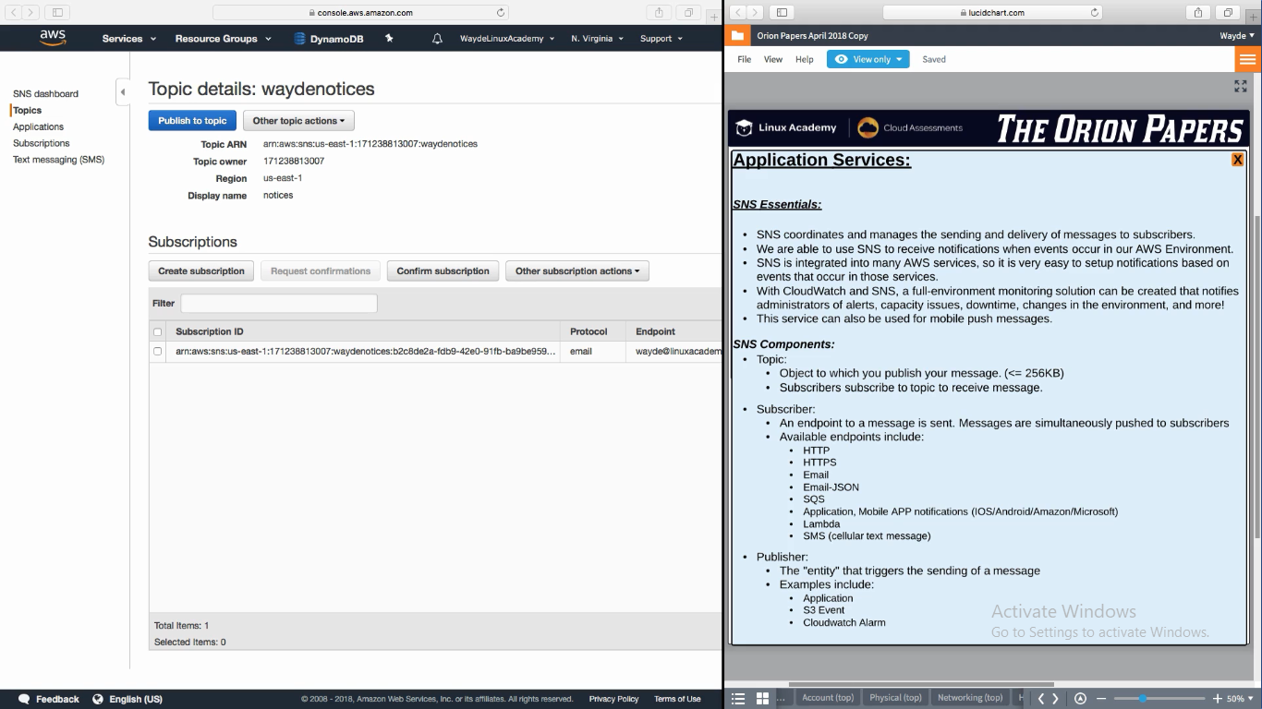

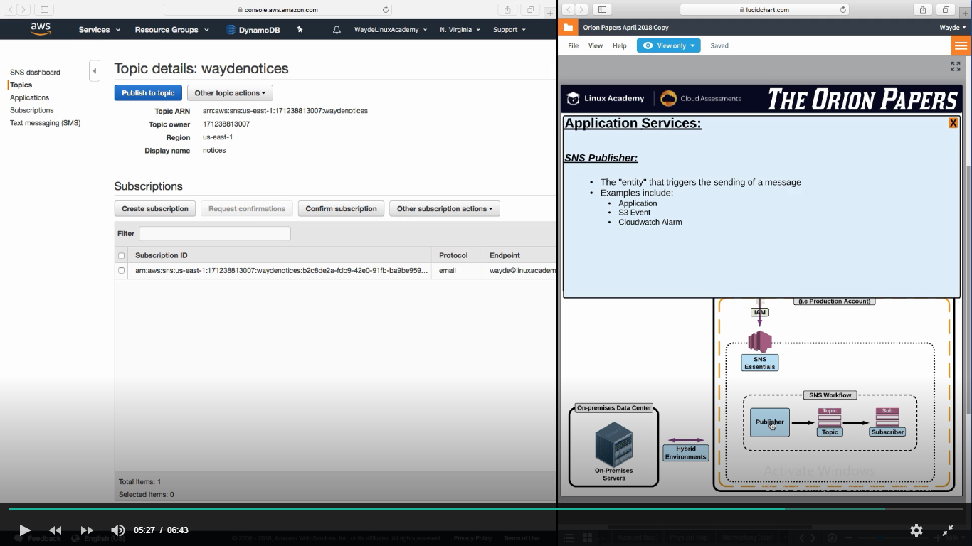

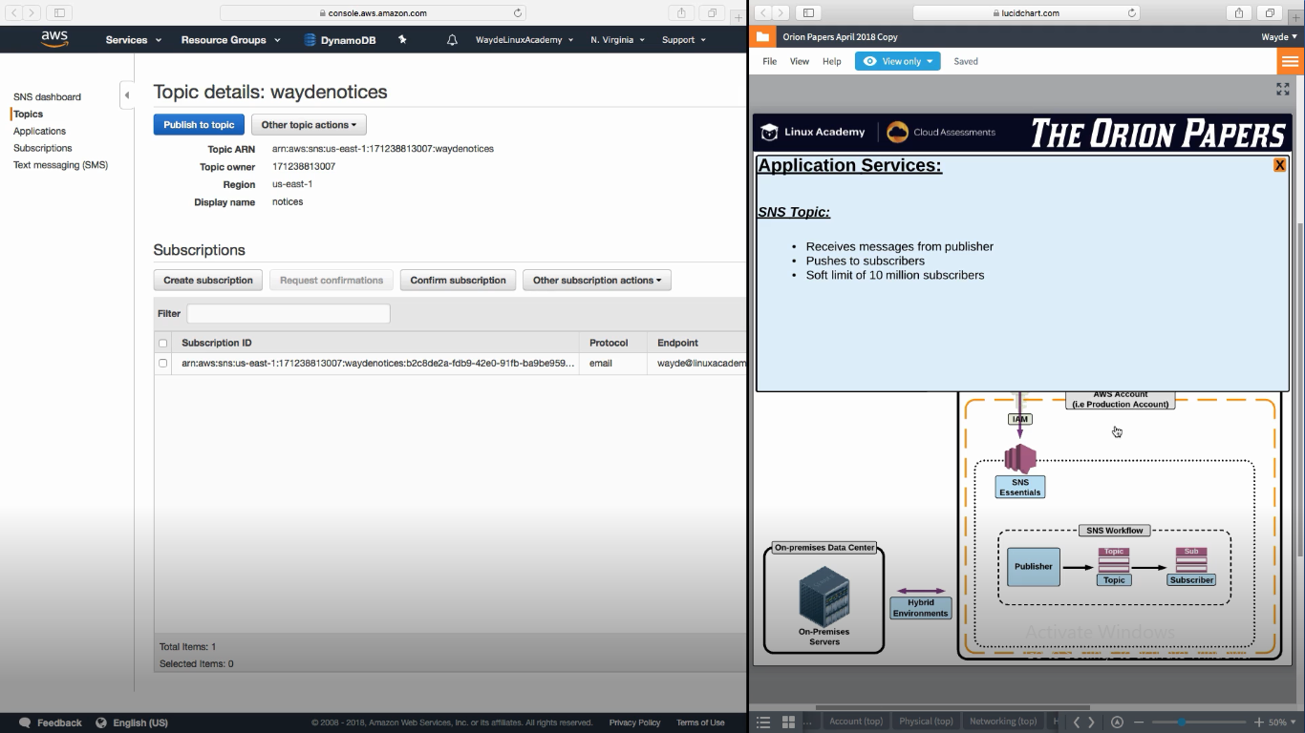

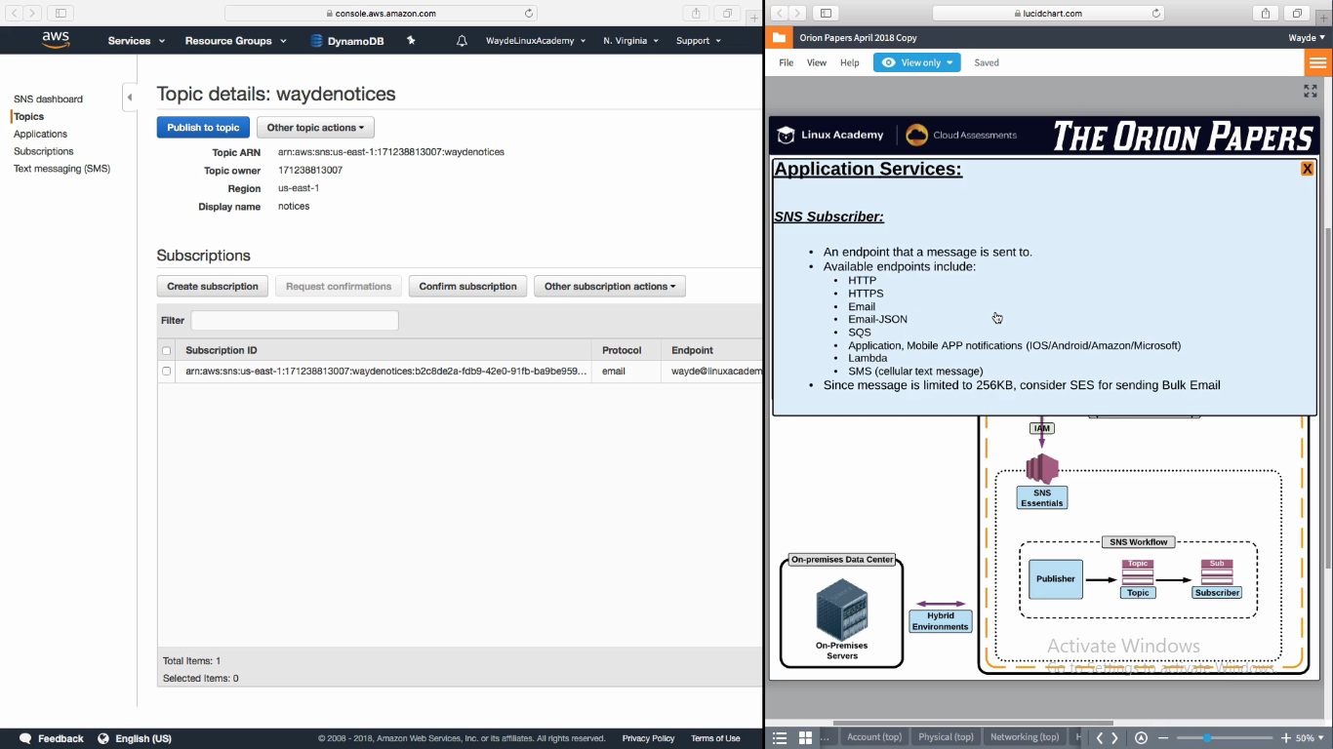

1. **SQS – Simple Queue Service**

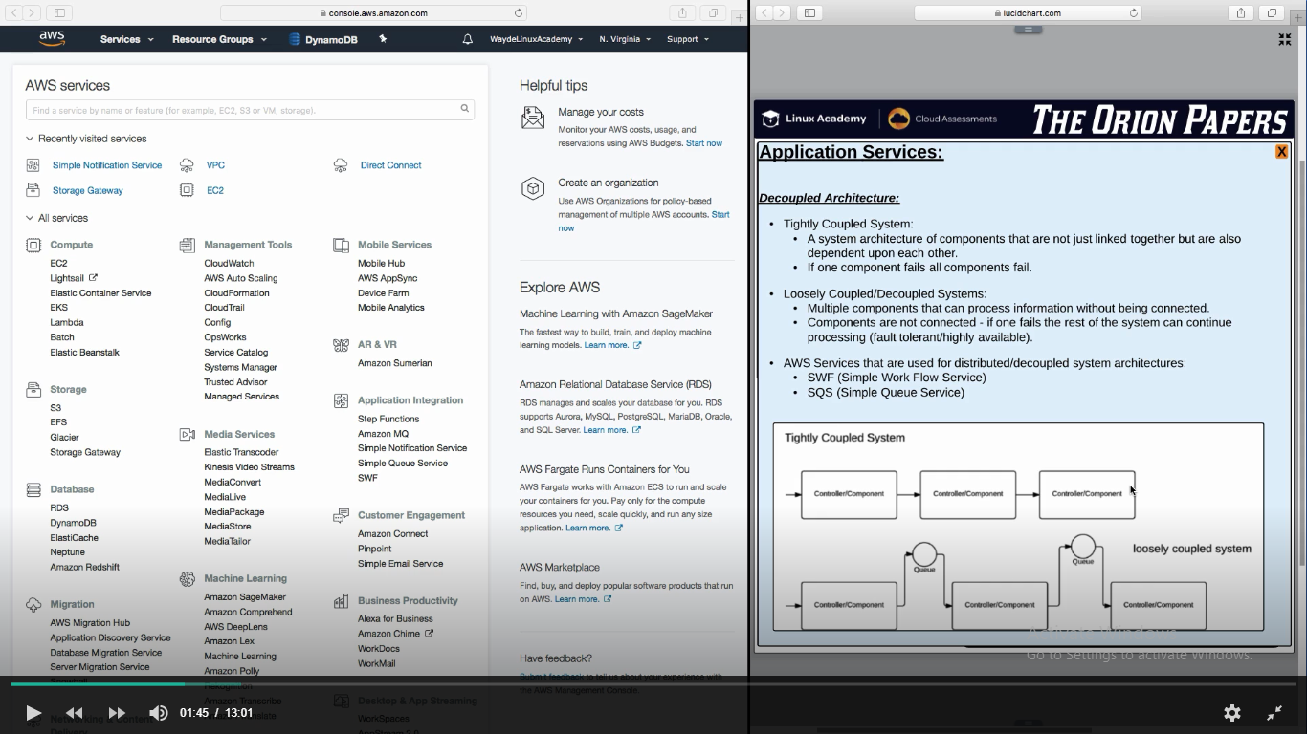

* 1. Provides a queue to write msg
  2. Worker instance when have opportunity to some work, will read the msg in the queue by poling the queue and then do whatever msg instructs
  3. It should be a HA queue across AZ
  4. Set Visibility time out on the queue for the worker instance to come to queue and read the msg. If that time lapse msg goes back to the queue and another worker node will try to read it

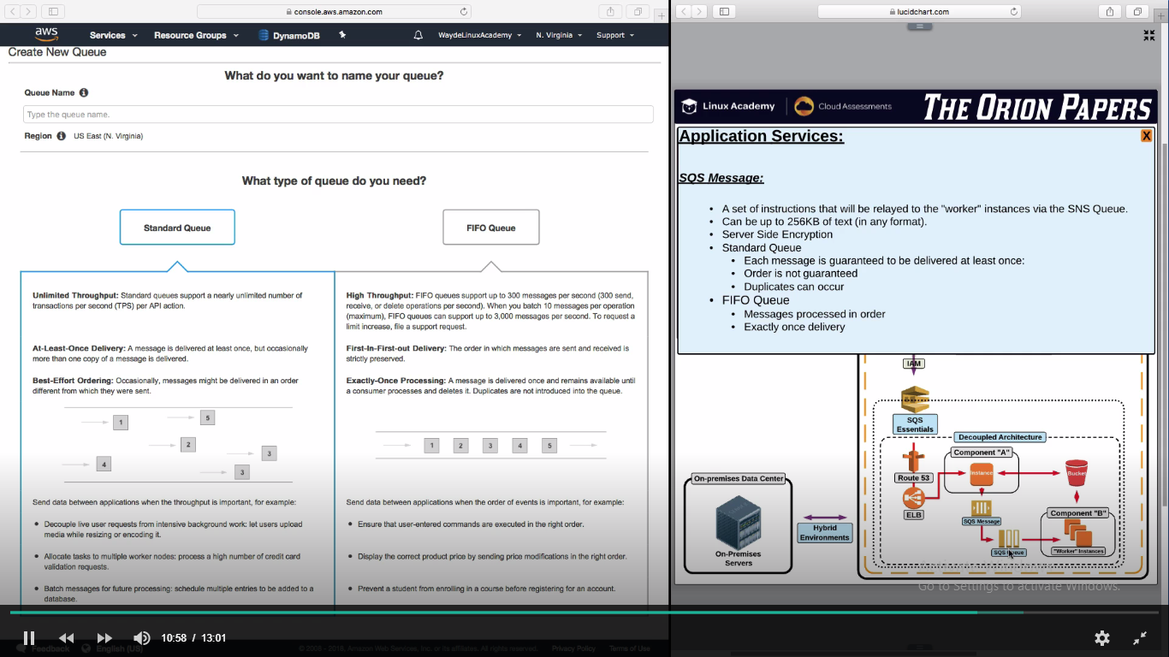

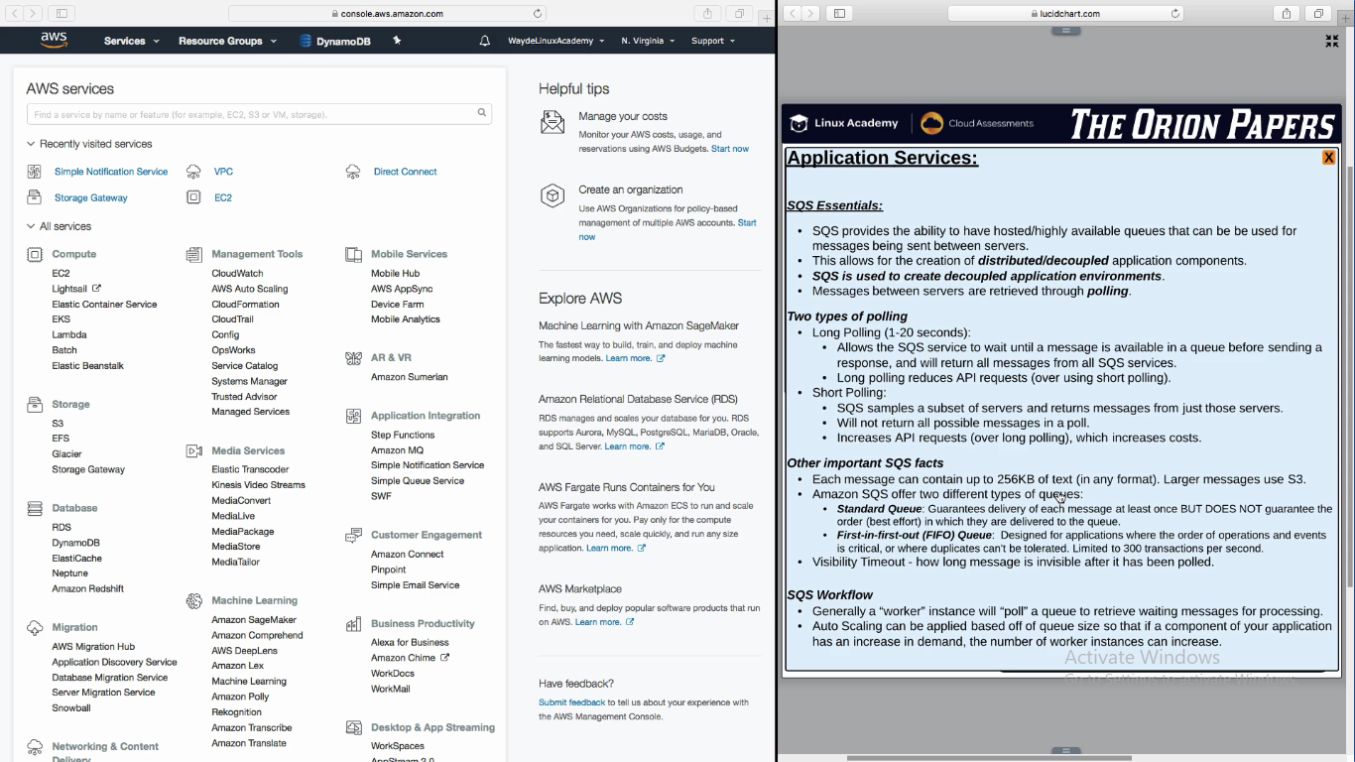

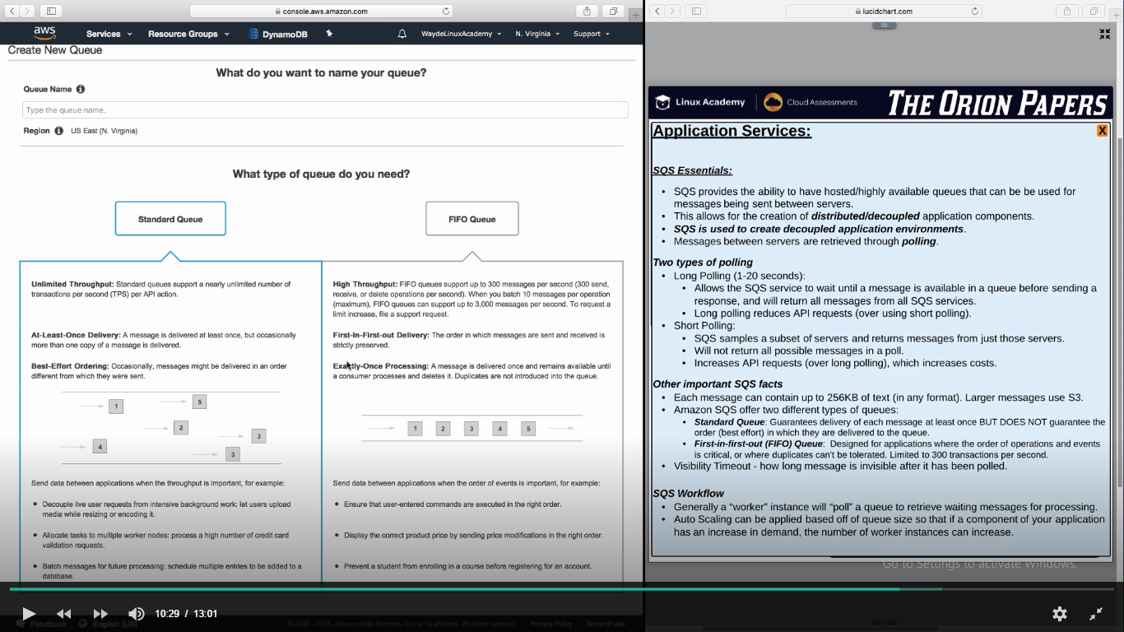

**Amazon Message Queue Service (Amazon MQ service)**

1. This uses apache MQ broker. Here we can initialize a Apache MQ broker and create topic and queue and add subscribers
2. Not scalable as like SNS or SQS
3. It runs on one single instance. It is not scalable. But we can make it HA by making one instance in one zone and another instance in another zone

Creation steps MQ broker in AWS console:

1. Create broker
2. Attach it to a VPC and SG. It take 15 min to create
3. By default runs in 8162 port

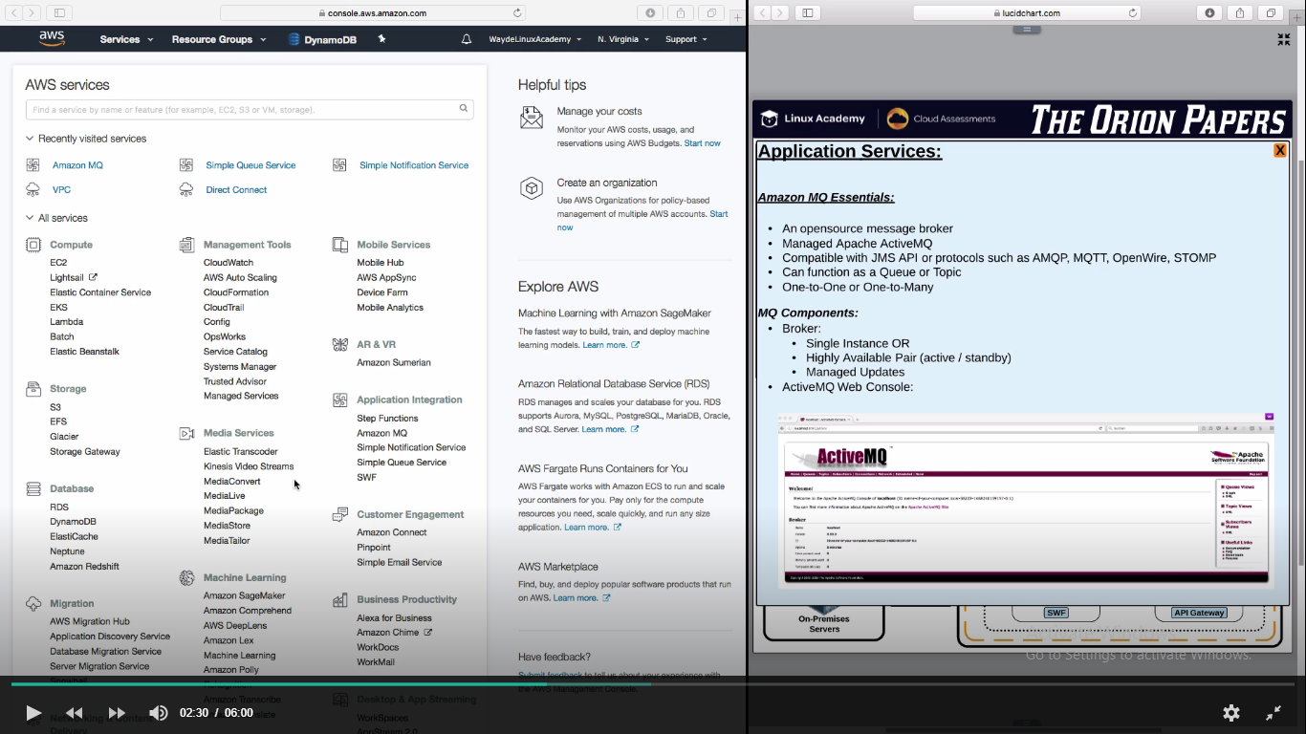

**SWF (Simple Work Framework)**

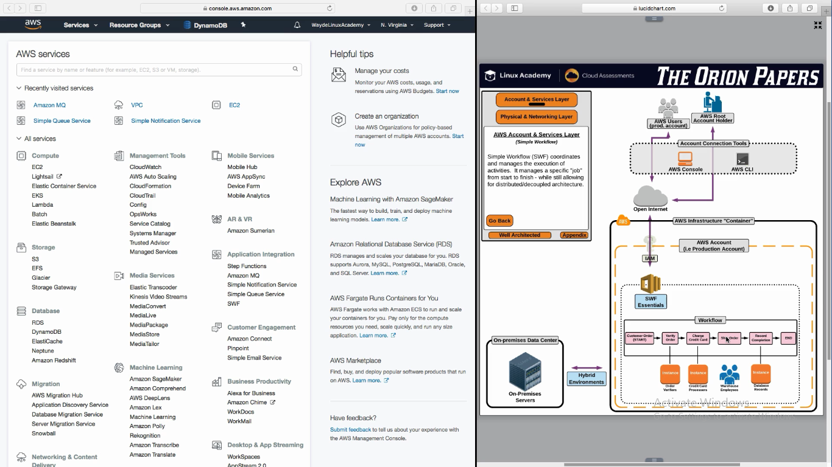

**SWF**

